FOUNDATION CHARITY
NETWORK EVENT!
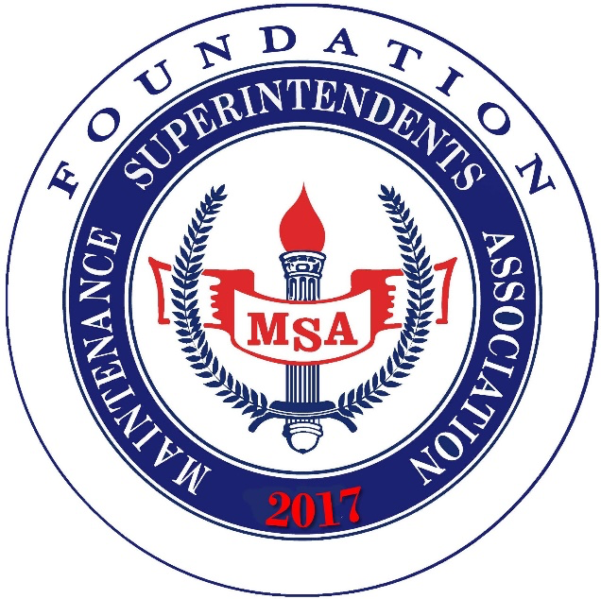
Kick off the 2025 MSA Conference
with other Conference attendees at the
FOUNDATION NETWORKING EVENT
to be held at
HANGAR 24 BREWERY
17877 Von Karman Ave., Irvine
on Monday, September 22 from 5:00 - 8:00 p.m.
$75.00 per person for food and drinks
We have reserved the courtyard for our event with plenty of seating and an adjacent area for cornhole!
Additional donations to the Foundation welcome!
(A $50 gift card will be given away in a drawing in recognition of each donation of $200 or more.)
QUESTIONS ? CALL (951) 235-1397

